COMPANY, LLC.

COUNTERINTELLIGENCE (CI) AND INSIDER THREAT (IT) SECURITY PROGRAM

COMPANY COUNTERINTELLIGENCE (CI) PROGRAM PLAN

1. (U) PURPOSE: The Company Counterintelligence (CI) Security Program will provide the structure needed to establish company-level CI operations in accordance with E.O. 13587 and DoD 5220.22-M Conforming Change #2. The program will establish guidelines for providing CI in support of company operations and activities worldwide, the use of CI for the deterrence or detection of Insider Threats, procedures for conducting and/or supporting CI data gathering, and designation of key personnel and/or departments necessary for the productive application of the program. The program will also:

- (U) Define “Insider Threat” and identify potential motivations which may lead to the theft of US Classified or Company Proprietary/Intellectual Property information.

- (U) Provide a procedure for the deterrence of intelligence gathering activities against US Classified or Company Proprietary/Intellectual Property information.

- (U) Create guidelines for investigating potential CI risks.

- (U) Satisfy compliance with DoD 5220.22-M, National Industrial Security Program Conforming Change #2.

- (U) Satisfy compliance with Executive Order 13587, Structural Reforms to Improve the Security of Classified Networks and the Responsible Sharing and Safeguarding of Classified Information.

2. (U) SUCCESS CRITERIA. Success of the Program is difficult to ascertain on a day to day basis due to the numerous variables incorporated into such a program. Success can be narrowly defined as the prevention of any loss of Classified, Proprietary, or Intellectual Information. However, actual loss or compromise may be difficult to detect or account for due to the very nature of an Insider Threat. The program’s success can be better defined in a broad view as the deterrence of Insider Threat activity through an active employee training and awareness program, consistent review of potential risk factors, and the early identification of personnel exhibiting risk factors.

3. (U) INSIDER THREAT DEFINED. Insider Threats are representative of a threat to an organization that comes from people within the organization, such as employees, former employees, contractors or business associates, who have inside information concerning the organization's security practices, data and computer systems. The insider may perform unauthorized acts against the company, such as information theft, system compromise, sabotage, corrupting processes, or any other act which would have a negative impact on the company or its operations.

4. (U) DETERRING INSIDER THREAT. Deterrence is most effective when a comprehensive detection program is in place and employees are encouraged to act as stakeholders in the protection of company resources. The best way to achieve this goal is to ensure that employees receive sufficient training in order to understand the full scope of how insider threats affect the government, the company, their co-workers, and themselves.

5. (U) CI RISK ASSESSMENTS. Risk Assessment is the process of identifying potential issues with employees which may lead them to take actions which could cause them to become an Insider Threat.

5.1. (U) Assessments are completed by the CI Program Manager based on data located through open sources, such as social media and legal databases, as well as verifiable information submitted by co-workers, supervisors, and managers. The intent of this information gathering is not to take direct action against any individual, but to identify personnel who may present a higher risk to the company. By identifying higher risk personnel the company will be better able to focus internal resources towards reducing potential loss and can assist the individual with methods for reducing their risk potential or exposure.

5.2. (U) Potential risk areas are identified as Money, Ideology, Conscience, Ego, Nationalism, Sexual Activity/Behavior, Personal Connections, Work Performance, and Work Violations. Each of these categories is rated on a scale of 0-10, with 0 representing a negligible risk and 10 indicating a potential extreme risk. Guidelines for each category level are identified in Attachment 1.

5.3 (U) Personnel will be identified as Low, Medium, or High Risk Potential. A graduated scale is utilized to calculate potential risks, based on a whole person concept. However, any individual exhibiting an extreme risk (level 10) in any category will automatically be considered as High Risk for the duration of time in which they exhibit signs that meet the level 4 guidelines for that category.

5.4 (U) Follow-up assessments of personnel risk categories will be completed when new information becomes available or if the individual takes actions which could mitigate previously identified issues.

6. (U) KEY PERSONNEL AND DEPARTMENTS: The CI Program requires coordination and partnership within the company in order to be effective.

6.1 (U) Managing Member/Company Owner.

6.2 (U) Chief Executive Officer.

6.3. (U) CI Program Manager.

6.4. (U) Program/Project Managers.

6.5. (U) CIO/IT Department.

6.6. (U) Executive Director of Human Resources/Human Resources Department.

6.7. (U) Legal Department.

6.8. (U) Company Employees.

Diagram 1: CI PROGRAM ORGANIZATION
Managing Member/ Company Owner
Key Personnel and Departments work with the CI Program Manager to ensure the success of the program.

Chief Executive Officer

CI Program Manager
Key Personnel and Departments

Company Employees serve a critical role in the day to day detection of potential risks.

Company Employee
Company Employee

Company Employee

Company Employee

Company Employee

Company Employee

Company Employee

7. (U) TRAINING:

7.1. (U) The CI Program Manager will complete training to develop the following skills:
6.1.1. (U) Counterintelligence Awareness and Reporting for DoD
6.1.2. (U) Developing a Security Education and Training Program
6.1.5. (U) Insider Threat
6.1.8. (U) Integrating CI and Threat Awareness into Security Program

7.2. (U) The CI Program Manager will be responsible for developing initial and annual refresher training for all employees to familiarize them with counterintelligence and potential risk categories which can affect an individual’s reliability, as well as awareness and reporting procedures, and program goals.

8. (U) INVESTIGATING POTENTIAL RISKS:

8.1. (U) High Risk. This category represents personnel who are either particularly vulnerable to manipulation or coercion or those whose beliefs or actions have a high potential to result in unauthorized acts against the company or the United States. High Risk personnel will be given priority when dedicating resources to observation and monitoring.

8.1.1. (U) Coordination will be made with IT and HR to further investigate potential wrongdoing. Access to the individual’s files or company e-mail account may be requested but can only be approved by the Company Owner or their designee.

8.1.2. (U) The CI Program Manager will coordinate with the IT Department to check for unusual activity related to the individual’s company account. Of particular interest will be indications of large transfers of files, access to information not related to the individual’s current project, or any other network activity which may present unauthorized activities.

8.1.3. (U) Transcripts of building access logs will be reviewed and the individual’s movements and building access will be monitored while on company property.

8.1.4. (U) Intervention by the CI Program Manager, the HR Department, or the individual’s supervisor may be appropriate if the issue creating the high risk is resolvable.

8.1.5. (U) Access to certain areas or information systems may be limited based on the type of risk presented by the individual. Any restrictions of this sort will be coordinated with the HR Department and the individual’s supervisor. Approval for this type of action must be received from the Company Owner or their designee.

8.2. (U) Medium Risk. This category represents personnel who have an increased risk of being vulnerable to manipulation or coercion or those whose beliefs or actions could potentially result in unauthorized acts against the company or the United States. Medium Risk personnel receive secondary priority when dedicating resources to observation and monitoring.

8.2.1. (U) Medium Risk personnel may be subject to the same monitoring as High Risk personnel if there is sufficient evidence that the individual may be involved in unauthorized actions or activities or if there are sufficient resources to monitor both High and Medium Risk personnel.

8.3. (U) Low Risk. This category represents personnel who have a negligible risk of being vulnerable to manipulation or coercion or those whose beliefs or actions do not present any substantial risk which could result in unauthorized acts against the company or the United States.

8.3.1. (U) Low Risk personnel typically do not require any additional monitoring outside standard security practices. However, they may be subject to any, or all, of the actions taken towards High Risk personnel if there is sufficient evidence that the individual may be involved in unauthorized actions or activities.

9. (U) REPORTING INCIDENTS TO CI PROGRAM:

9.1. All company employees, managers, and consultants will be encouraged to report potential issues to the CI Program Manager. Reports may be made verbally or in writing and steps will be taken to ensure that any reports remain confidential.

9.2. The CI Program Manager will validate any information provided in order to remove information which may have been submitted due to a personal bias, as well as any data that is incorrect or unrelated.

10. (U) REQUESTS FOR CI SUPPORT: Any manager or department head may request CI Support in order to investigate potential risks within their department or section.

11. (U) RESPONDING TO MALICIOUS ACTIVITY:

11.1. Malicious activities affecting company operations or information will be immediately investigated. A joint investigation involving the CI Program Manager, IT Department, and HR Department will be performed and the manager for any affected resources will be briefed on the malicious activity.

11.2. An activity report will be generated by the CI Program Manager regarding any malicious activities and will identify key findings relating to the incident. At a minimum the report will include the type of activity, how the malicious activity was conducted, and potential safeguards against future malicious activity of a similar nature.

12. (U) REPORTS TO COGNIZANT SECURITY AGENCY (CSA):

12.1. Any issues involving US Classified information will be immediately up-channeled to the owning agency.

ATTACHMENT 1
RISK MATRIX CATEGORIES AND GUIDELINES

Category | Level | Guideline
Money | 0 | No issues identified or any issues are effectively mitigated
Money | 1 | Minimal issues, concerns, or more serious issues are partially mitigated
Money | 2
Money | 3
Money | 4 | Issues or concerns commensurate with current economic standings
Money | 5
Money | 6
Money | 7 | Above average issues in excess of current economic standings
Money | 8 | Above average issues in excess of current economic standings
Money | 9 | Above average issues in excess of current economic standings
Money | 10 | Serious issues, debts, foreclosures or extravagant activities far beyond current economic standing
Category | Level | Guideline
Ideology | 0 | No issues identified or any issues are effectively mitigated
Ideology | 1 | Individual expresses some interest in certain political, religious, or personal beliefs
Ideology | 2
Ideology | 3
Ideology | 4 | Individual has strong political, religious, or personal beliefs. The force behind these beliefs is commensurate with, or slightly above, current societal standards
Ideology | 5
Ideology | 6
Ideology | 7 | Individual has very strong political, religious, or personal beliefs and has expressed that these beliefs are above other societal restrictions
Ideology | 8
Ideology | 9
Ideology | 10 | Has extreme political, religious, or personal beliefs above societal restrictions and actively works to promote or carry out these beliefs
Category | Level | Guideline
Conscience | 0 | No issues identified or any issues are effectively mitigated
Conscience | 1 | Has minor ethical or moral concerns regarding company activities or products. Alternatively, if working on US contracts, the individual has minor ethical or moral concerns regarding US policies or activities
Conscience | 2
Conscience | 3
Conscience | 4 | Has ethical or moral concerns regarding company activities or products. Alternatively, if working on US contracts, the individual has ethical or moral concerns regarding US policies or activities
Conscience | 5
Conscience | 6
Conscience | 7 | Expresses strong ethical or moral concerns regarding company activities or products. Alternatively, if working on US contracts, the individual expresses strong ethical or moral concerns regarding US policies or activities
Conscience | 8
Conscience | 9
Conscience | 10 | Consistently makes extreme expressions, or demonstrates against, company products or US policies or activities (if working on US contracts)

Category | Level | Guideline
Ego | 0 | No issues identified or any issues are effectively mitigated
Ego | 1 | Minimal issues, or more serious issues are partially mitigated
Ego | 2
Ego | 3
Ego | 4 | Individual has an above average feeling of self-importance and may easily feel slighted under normal circumstances
Ego | 5
Ego | 6
Ego | 7 | Individual feels that they lack importance, feels that they have been treated unfairly, or feels that they have been wronged (either real or imagined)
Ego | 8
Ego | 9
Ego | 10 | Consistently expresses or displays a belief that they are superior and/or that their importance is rarely, if ever, recognized
Category | Level | Guideline
Nationalism | 0 | No issues identified or any issues are effectively mitigated
Nationalism | 1 | Has ties to a foreign country either due to dual-citizenship, family relations, foreign friends, or presents some other connection to a foreign country
Nationalism | 2
Nationalism | 3
Nationalism | 4 | Expresses feelings of connection with a foreign country or government above that of the US
Nationalism | 5
Nationalism | 6
Nationalism | 7 | Makes repeated verbal, written, or implied statements identifying a desire to aid a foreign country or government
Nationalism | 8
Nationalism | 9
Nationalism | 10 | Expresses great regard for foreign country or government and demonstrates a strong desire or intent to help the foreign country
Category | Level | Guideline
Sexual Activity/Behavior | 0 | No issues identified or any issues are effectively mitigated
Sexual Activity/Behavior | 1 | Minor issues due to natural age or maturity, or more serious issues are partially mitigated
Sexual Activity/Behavior | 2
Sexual Activity/Behavior | 3
Sexual Activity/Behavior | 4 | Potential issues due to personal proclivities for non-traditional activities and potential for manipulation
Sexual Activity/Behavior | 5
Sexual Activity/Behavior | 6
Sexual Activity/Behavior | 7 | High risk due to hidden lifestyle or potential for manipulation or coercion
Sexual Activity/Behavior | 8
Sexual Activity/Behavior | 9
Sexual Activity/Behavior | 10 | Very high risk of being manipulated or coerced due to sexual activities or behavior

Category | Level | Guideline
Personal Connections | 0 | No issues identified or any issues are effectively mitigated
Personal Connections | 1 | Has friendship ties to individual(s) working at competing companies
Personal Connections | 2
Personal Connections | 3
Personal Connections | 4 | Has personal ties to individual(s) working at competing companies. These ties exceed basic friendship and may be associated with shared history, goals, or needs
Personal Connections | 5
Personal Connections | 6
Personal Connections | 7 | Has very strong ties to individual(s) working at competing companies. These ties are likely emotional in nature and may be associated with a long term relationship
Personal Connections | 8
Personal Connections | 9
Personal Connections | 10 | Extreme ties of obligation or connection to individual(s) working at competing companies
Category | Level | Guideline
Work Performance | 0 | No issues identified or any issues are effectively mitigated
Work Performance | 1 | Minimal issues, concerns, or more serious issues are partially mitigated
Work Performance | 2
Work Performance | 3
Work Performance | 4 | Some issues or concerns
Work Performance | 5 | Some issues or concerns
Work Performance | 6 | Some issues or concerns
Work Performance | 7 | Above average issues that have the potential to require termination
Work Performance | 8
Work Performance | 9
Work Performance | 10 | Serious issues which could result in immediate termination
Category | Level | Guideline
Work Violations | 0 | No issues identified or any issues are effectively mitigated
Work Violations | 1 | Minimal issues, concerns, or more serious issues are partially mitigated
Work Violations | 2
Work Violations | 3
Work Violations | 4 | Some issues or concerns
Work Violations | 5 | Some issues or concerns
Work Violations | 6 | Some issues or concerns
Work Violations | 7 | Above average issues that have the potential to require termination
Work Violations | 8
Work Violations | 9
Work Violations | 10 | Serious issues which could result in immediate termination

ATTACHMENT 2
CI RISK PROCESS FLOWCHART

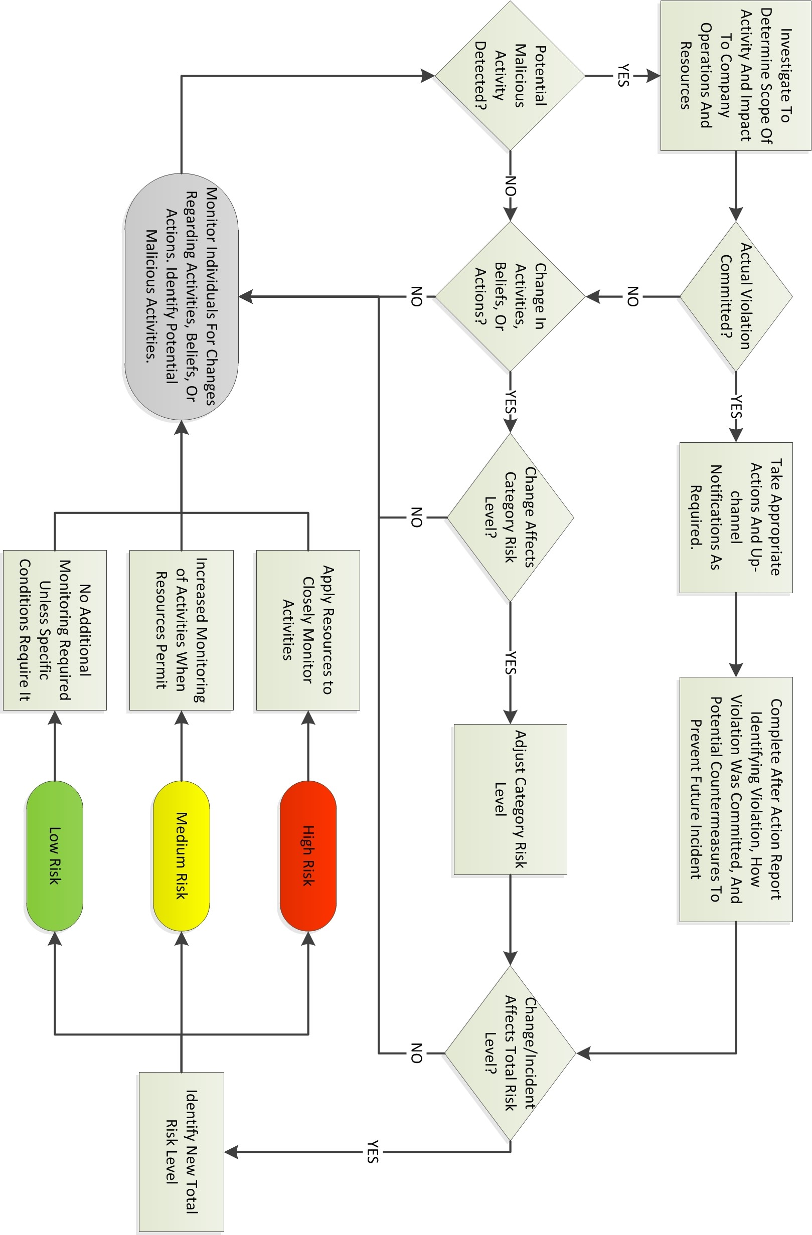
ATTACHMENT 3
TERMS & DEFINITIONS OF INTEREST
FOR DoD COUNTERINTELLIGENCE PRODESSIONALS
Office of Counterintelligence (DXC)
Defense CI & HUMINT Center
Defense Intelligence Agency

http://www.cdse.edu/documents/toolkits-fsos/ci-definitions.pdf

